***TRAFFIC MANAGEMENT SYSTEM***

***ABSTRACT:***

***In response to the escalating challenges of urban traffic congestion, our IoT-based Traffic Management project introduces a comprehensive solution harnessing the power of the Internet of Things. By deploying a network of strategically positioned sensors, real-time data analysis, and adaptive traffic control, our system optimizes traffic flow, mitigates congestion, and enhances road safety. With an emphasis on real-time emergency response, user-friendly interfaces, and data-driven decision-making, this project represents a significant step towards creating smarter and more efficient urban transportation networks, ultimately fostering sustainable and livable cities for the future.***

**Flowchart:**

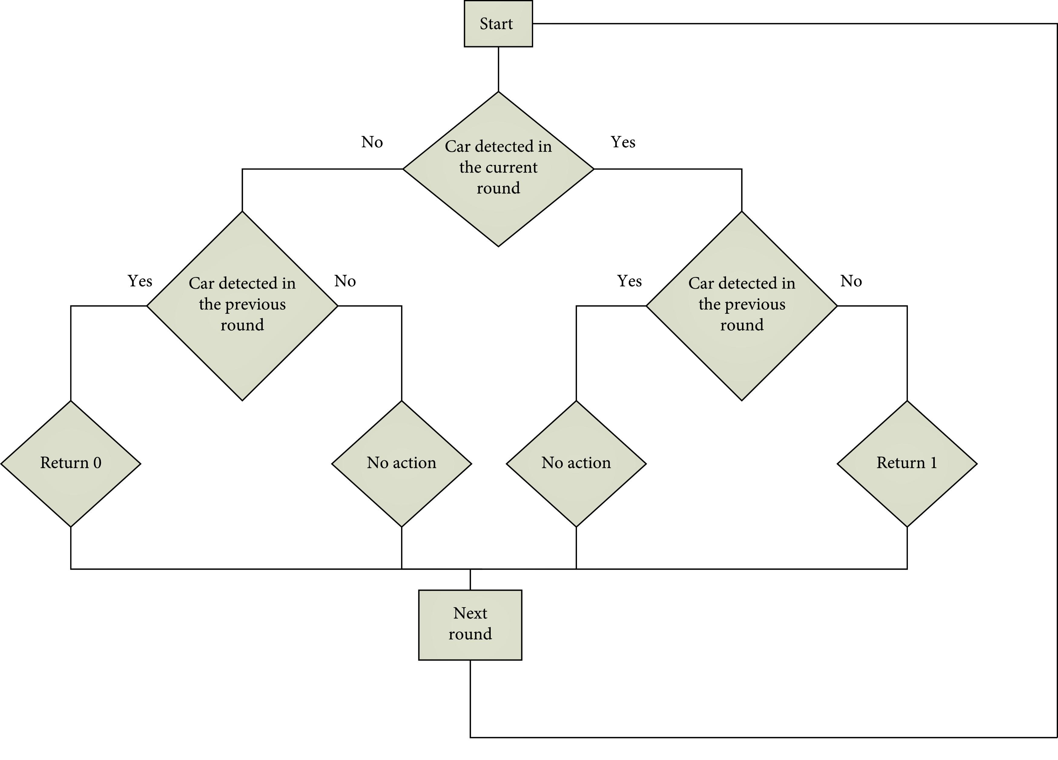

|  |  |  |  |  |  |  |  |
| --- | --- | --- | --- | --- | --- | --- | --- |
| **Analytical Context / Geographic Scope** | **Analytical Tools / Methodologies :**  **Sketch Planning** | **Analytical Tools / Methodologies : Travel Demand Models** | **Analytical Tools /**  **Methodologies : Analytical / Deterministic Tools ( HCM Based )** | **Analytical Tools / Methodologies : Traffic Optimization** | **Analytical Tools / Methodologies : Macroscopic Simulation** | **Analytical Tools / Methodologies : Mesoscopic Simulation** | **Analytical Tools / Methodologies : Microscopic Simulation** |
| Planning:  Isolated Location | **○** | **○** | • | ∅ | **○** | **○** | **○** |
| Planning:  Segment | • | **○** | • | **○** | ∅ | ∅ | ∅ |
| Planning:  Corridor / Small Network | ∅ | • | **○** | **○** | ∅ | ∅ | ∅ |
| Planning:  Region | ∅ | • | Not Applicable | Not Applicable | Not Applicable | Not Applicable | Not Applicable |
| Design:  Isolated Location | Not Applicable | Not Applicable | • | • | • | ∅ | • |
| Design: Segment | Not Applicable | **○** | • | ∅ | • | • | • |
| Design:  Corridor / Small Network | Not Applicable | ∅ | **○** | **○** | • | • | • |
| Design: Region | Not Applicable | ∅ | Not Applicable | Not Applicable | **○** | **○** | ∅ |
| Operations / Construction:  Isolated Location | Not Applicable | Not Applicable | • | • | • | ∅ | • |
| Operations / Construction:  Segment | ∅ | **○** | • | • | • | • | • |
| Operations / Construction:  Corridor / Small Network | Not Applicable | ∅ | **○** | ∅ | • | • | • |
| Operations / Construction:  Region | Not Applicable | ∅ | Not Applicable | Not Applicable | ∅ | **○** | ∅ |

**Steps to analyze traffic light**

***Step1:***

***Review Key Definitions:*** Understand the definitions associated with each traffic light color (e.g., green for good, yellow for caution, red for issues).

***Step2:***

***Gather Data:*** Collect data or information relevant to the traffic light management system.

***Step3:***

***Identify Metrics:*** Determine the specific metrics or criteria used to assign traffic light statuses.

***Step4:***

***Examine Current Status:*** Assess the current status of tasks, projects, or processes using the traffic light system.

***Step 5:***

***Analyze Trends:*** Look for patterns or trends in how statuses change over time.

***Step 6:***

***Compare to Targets:*** Compare the current statuses to predefined targets or goals.

***Step 7:***

***Identify Deviations:*** Highlight areas where there are deviations from expected or desired statuses.

***Step 8:***

***Prioritize Actions:*** Determine which tasks or areas require immediate attention based on red or yellow statuses.

***Step 9:***

***Develop Action Plans:*** Create action plans to address issues and improve performance.

***Step 10:***

***Monitor and Adjust:*** Continuously monitor the system, make necessary adjustments, and track progress towards improving statuses over time.

**ABSTRACT:**

***Traffic Signal Management System represents a transformative approach to urban traffic control. By utilizing advanced IoT technology, it revolutionizes how traffic signals operate. Real-time data from sensors at intersections informs the system, allowing for dynamic adjustments to signal timings based on traffic conditions. This adaptability significantly reduces congestion, decreases travel time, and improves overall traffic efficiency. This innovative system not only benefits commuters but also contributes to safer roads and more sustainable urban environments, aligning with the vision of intelligent and responsive traffic signal management.***

***IoT-Based Traffic Management System is a cutting-edge solution for assessing urban traffic challenges. Through a network of strategically placed sensors and sophisticated data analytics, it optimizes traffic flow, reduces congestion, and enhances road safety. The system’s adaptability in real-time signal control and its ability to provide timely information to drivers make it a cornerstone for smarter, more efficient urban transportation. By leveraging IoT technology, this innovative system takes us a step closer to realizing the concept of intelligent and sustainable cities with responsive traffic management solutions that prioritize the well-being of both commuters and the urban environment.***

**DIAGRAM:**

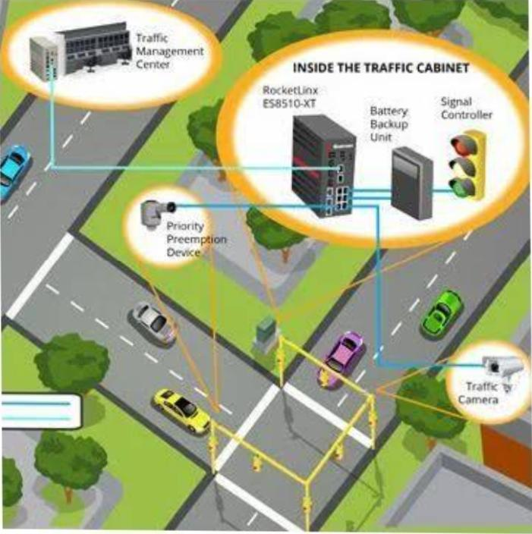

**PROGRAM:**

#include <stdio.h>

#include <stdlib.h>

#include <time.h>

#include <unistd.h>

Typedef enum { RED, GREEN, YELLOW } TrafficLightState;

Void delay(int seconds)

{

Time_t start_time = time(NULL);

While (time(NULL) < start_time + seconds);

}

Void changeTrafficLight(TrafficLightState* state)

{

If (*state == RED)

*state = GREEN;

Else if (*state == GREEN)

*state = YELLOW;

Else

*state = RED;

}

Int main()

{

TrafficLightState trafficLight = RED

For (int I = 0; I < 10; i++)

{

Printf(“Traffic light is %s\n”, trafficLight == RED ? “RED” : (trafficLight == GREEN ? “GREEN” : “YELLOW”));

Delay(2); // Simulate a 2-second interval

changeTrafficLight(&trafficLight);

}

Return 0;

}

**Code:**

<html>

<head>

<title>C Program</title>

</head>

<body>

<pre>

#include &lt;stdio.h&gt;

#include &lt;stdlib.h&gt;

#include &lt;time.h&gt;

#include &lt;unistd.h&gt;

Typedef enum { RED, GREEN, YELLOW } TrafficLightState;

Void delay(int seconds) {

Time_t start_time = time(NULL);

While (time(NULL) < start_time + seconds);

}

Void changeTrafficLight(TrafficLightState* state) {

If (*state == RED)

*state = GREEN;

Else if (*state == GREEN)

*state = YELLOW;

Else

*state = RED;

}

Int main() {

TrafficLightState trafficLight = RED;

For (int I = 0; I < 10; i++) {

Printf(“Traffic light is %s\n”, trafficLight == RED ? “RED” : (trafficLight == GREEN ? “GREEN” : “YELLOW”));

Delay(2); // Simulate a 2-second interval

changeTrafficLight(&trafficLight);

}

Return 0;

}

</pre>

</body>

</html>

**PRINCIPLE OF IOT DESIGN:**

***IoT design, short for Internet of Things design, encompasses the creative process of developing connected devices and systems that can collect and exchange data over the internet. It involves a synergy of hardware, software, and user experience considerations to create seamless and efficient IoT solutions. Effective IoT design focuses on optimizing power consumption, ensuring data security, and delivering a user-friendly interface. It plays a pivotal role in shaping the future of smart homes, industrial automation, healthcare, and numerous other domains by enabling devices to communicate and operate in an interconnected, intelligent manner.***

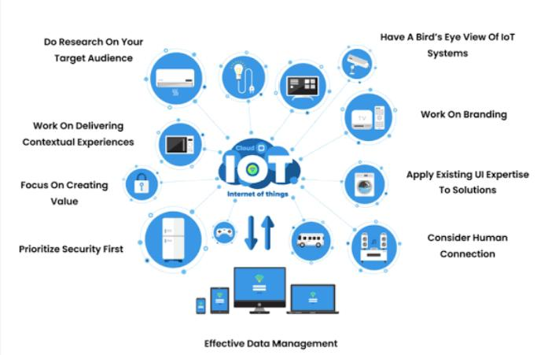**IOT DESIGN**: